San Francisco Bay University  
EE461 Verilog-HDL  
 Homework #2 Date: 10/04/2024

S A SABBIRUL MOHOSIN NAIM (20176)

**1.**

// Code your design here

// Code your testbench here

// or browse Examples

module arithmetic_operations();

reg signed [3:0] a, b;

reg signed [4:0] b5bit;

reg signed [3:0] result_add, result_sub, result_mul, result_mod;

initial begin

// Assign values

a = 4'b1111; // 'a' is 4'b1111, which is -1 in signed 4-bit

b = -5'b00010; // 'b' is -2 in 5-bit

b5bit = -5'b01xz; // 'b' contains unknown values

// Perform arithmetic operations with valid b = -2

result_add = a + b[3:0]; // Using lower 4 bits of 'b'

result_sub = a - b[3:0];

result_mul = a * b[3:0];

result_mod = a % b[3:0];

// Display the results for b = -5'b00010

$display("When b = -5'b00010:");

$display("a + b = %d", result_add);

$display("a - b = %d", result_sub);

$display("a * b = %d", result_mul);

$display("a %% b = %d", result_mod);

// Operations with b5bit = -5'b01xz, handle unknown 'x' or 'z' bits

result_add = a + b5bit[3:0];

result_sub = a - b5bit[3:0];

result_mul = a * b5bit[3:0];

result_mod = a % b5bit[3:0];

// Display the results for b = -5'b01xz

$display("When b = -5'b01xz:");

$display("a + b = %d", result_add);

$display("a - b = %d", result_sub);

$display("a * b = %d", result_mul);

$display("a %% b = %d", result_mod);

end

endmodule

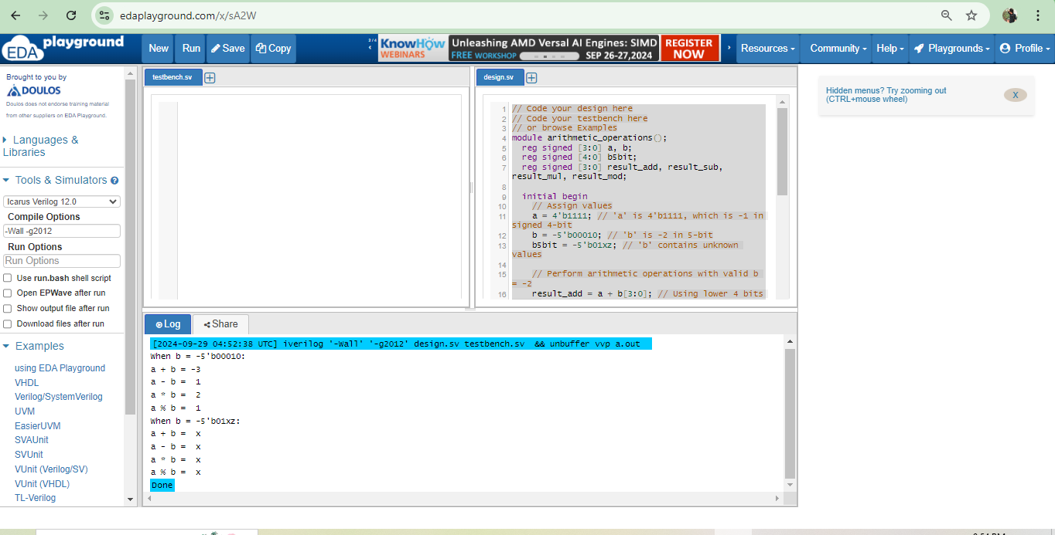

**2.**

// Code your design here

module compare_values();

reg [1:0] a_2bit; // 2-bit value of 'a'

reg [2:0] b_3bit; // 3-bit value of 'b'

reg [3:0] a_4bit; // 4-bit value of 'a' for the second test

initial begin

// Case 1: a = 2'b1z and b = 3'b11z

a_2bit = 2'b1z; // 'a' = 1z (unknown bit in 2-bit)

b_3bit = 3'b11z; // 'b' = 11z (unknown bit in 3-bit)

// Perform comparisons and display results for a = 2'b1z, b = 3'b11z

$display("Case 1: a = 2'b1z and b = 3'b11z:");

$display("a > b: %b", (a_2bit > b_3bit));

$display("a >= b: %b", (a_2bit >= b_3bit));

$display("a < b: %b", (a_2bit < b_3bit));

$display("a <= b: %b", (a_2bit <= b_3bit));

// Case 2: a = 4'b01xz

a_4bit = 4'b01xz; // 'a' = 01xz (unknown bits in 4-bit)

// Perform comparisons with a 4-bit value of 'a'

$display("\nCase 2: a = 4'b01xz and b = 3'b11z:");

$display("a > b: %b", (a_4bit > b_3bit));

$display("a >= b: %b", (a_4bit >= b_3bit));

$display("a < b: %b", (a_4bit < b_3bit));

$display("a <= b: %b", (a_4bit <= b_3bit));

end

endmodule

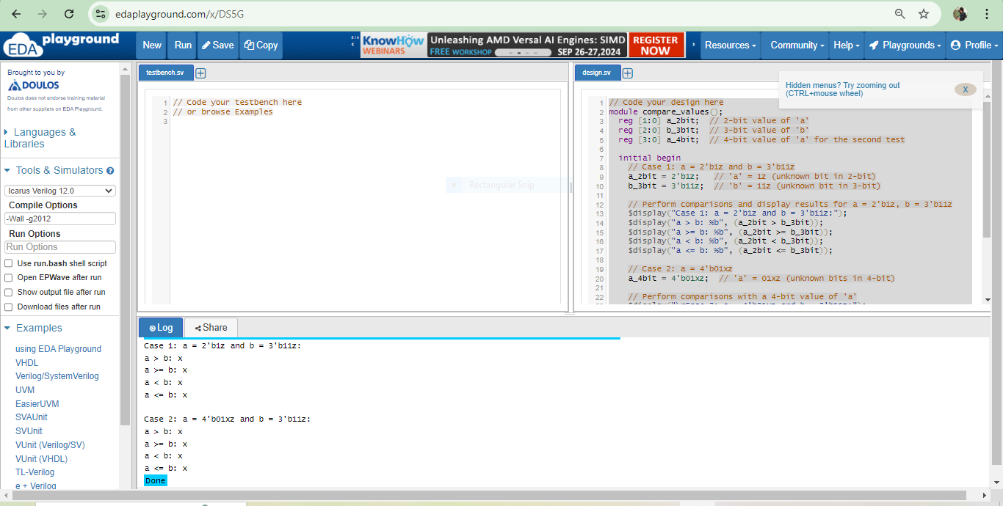

**3.**

if a = 4’b01xz and b = 4’bzx10 for (a===b)

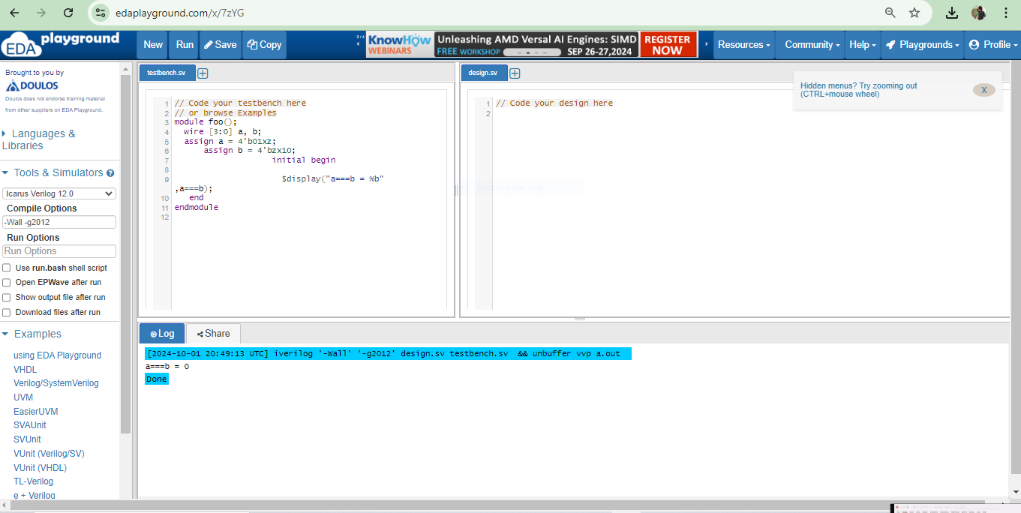

**//For (a !== b )**

module foo();

wire [3:0] a, b;

assign a = 4'b01xz;

assign b = 4'bzx10;

initial begin

$display ("a !== b =%b" , a !== b);

end

endmodule

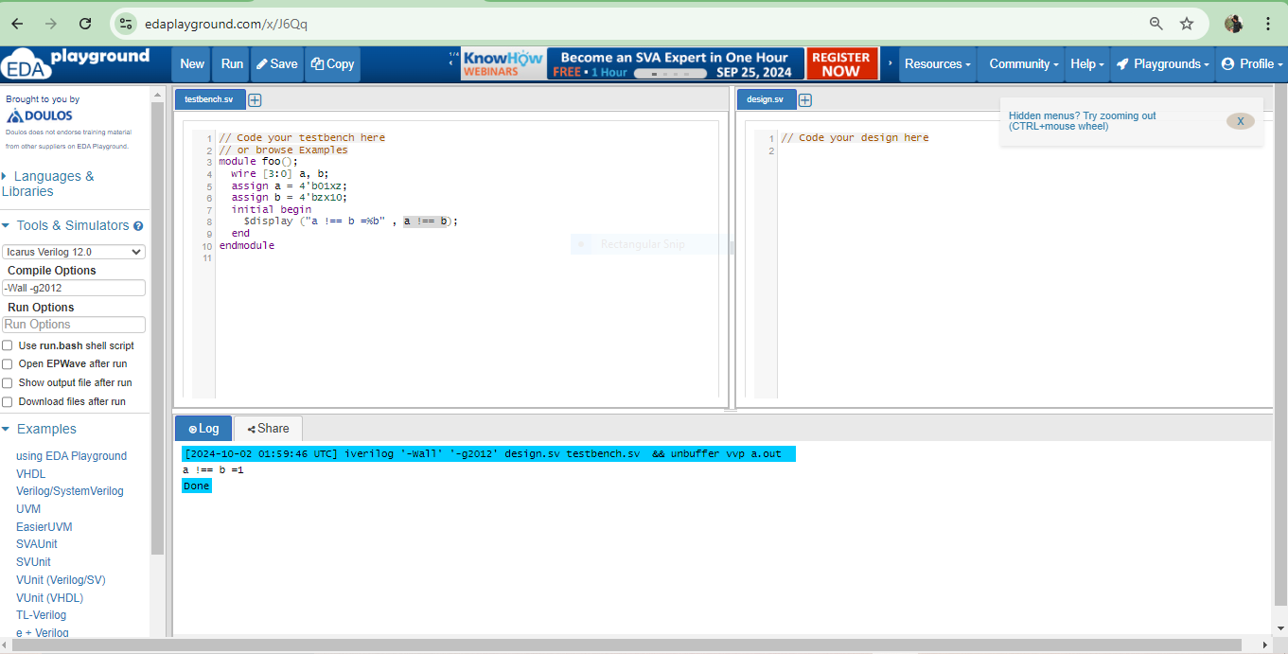

**//For (a == b)**

// Code your testbench here

// or browse Examples

module foo();

wire [3:0] a, b;

assign a = 4'b01xz;

assign b = 4'bzx10;

initial begin

$display ("(a == b) =%b" , (a == b) );

end

endmodule

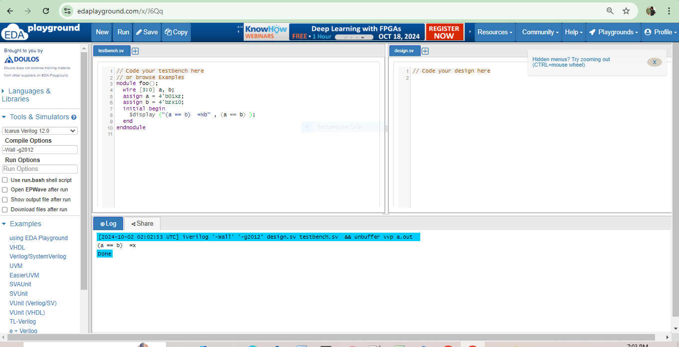

**//for (a != b)**

// Code your testbench here

// or browse Examples

module foo();

wire [3:0] a, b;

assign a = 4'b01xz;

assign b = 4'bzx10;

initial begin

$display ("a != b =%b" , a != b );

end

endmodule

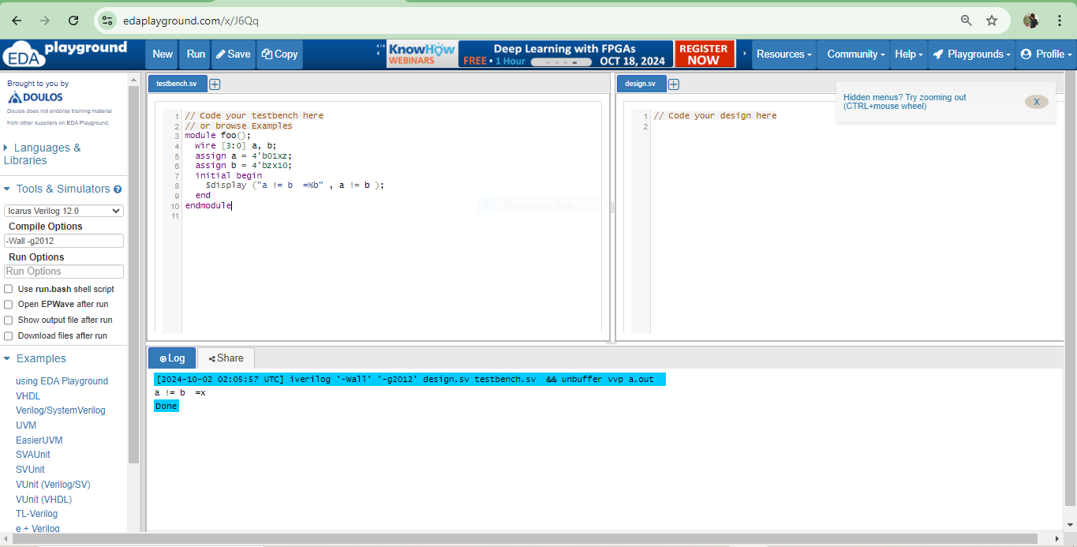

//If a = 4'b01zz and b=4'b0100;

//For a == b

// Code your testbench here

// or browse Examples

module foo();

wire [3:0] a, b;

assign a = 4'b01zz;

assign b= 4'b0100;

initial begin

$display ("a == b =%b" , a == b );

end

endmodule

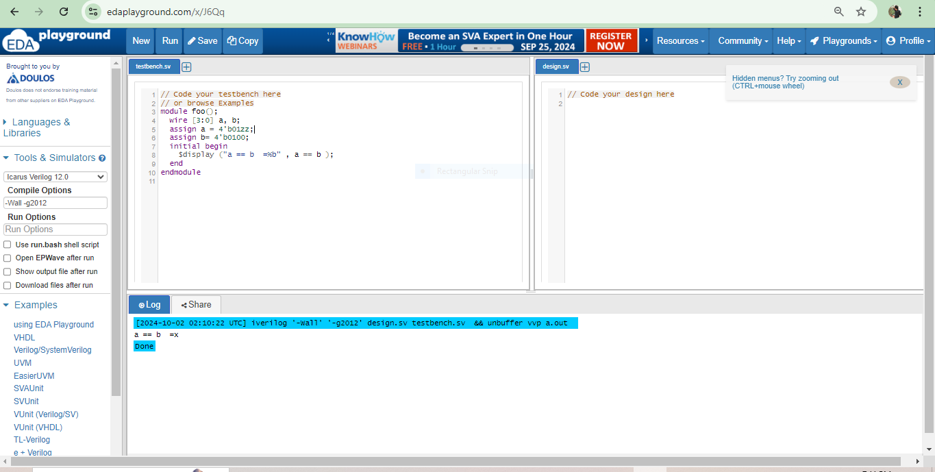

**// for a!=b**

// or browse Examples

module foo();

wire [3:0] a, b;

assign a= 4'b01zz;

assign b=4'b0100;

initial begin

$display ("(a!= b) =%b" , (a!= b) );

end

endmodule

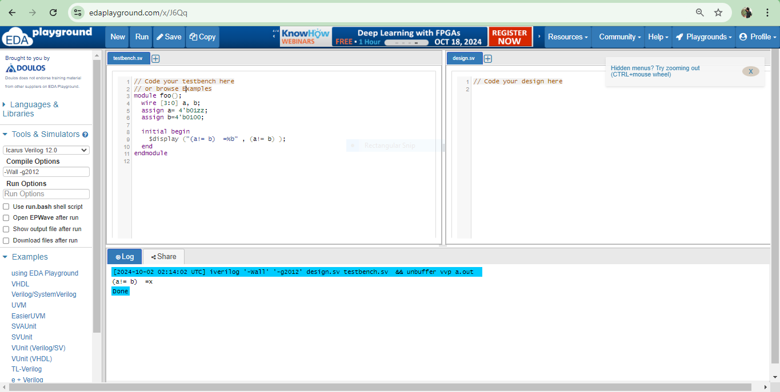

**If a = 4’b01xz and b = 4’b01xz;**

**//for** (a === b)

// Code your testbench here

// or browse Examples

module foo();

wire [3:0] a, b;

assign a=4'b01xz;

assign b=4'b01xz;

initial begin

$display ("(a === b) =%b" , (a === b) );

end

endmodule

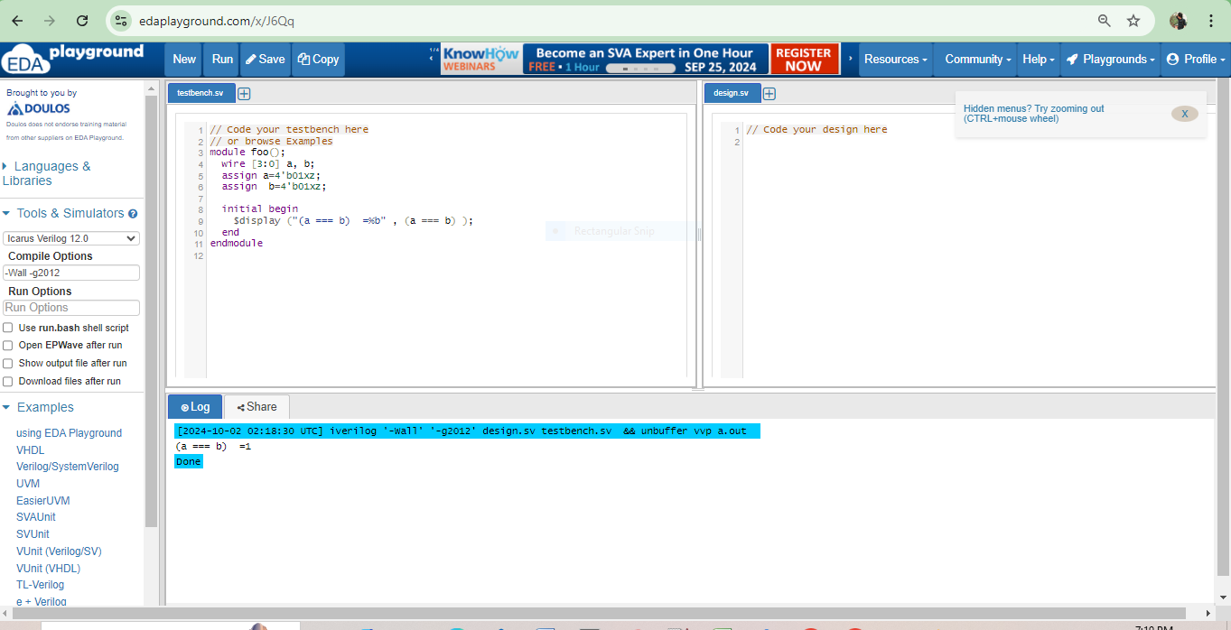

Now I just give the code and output screenshots together ( no code separately).

**//for a!==b**

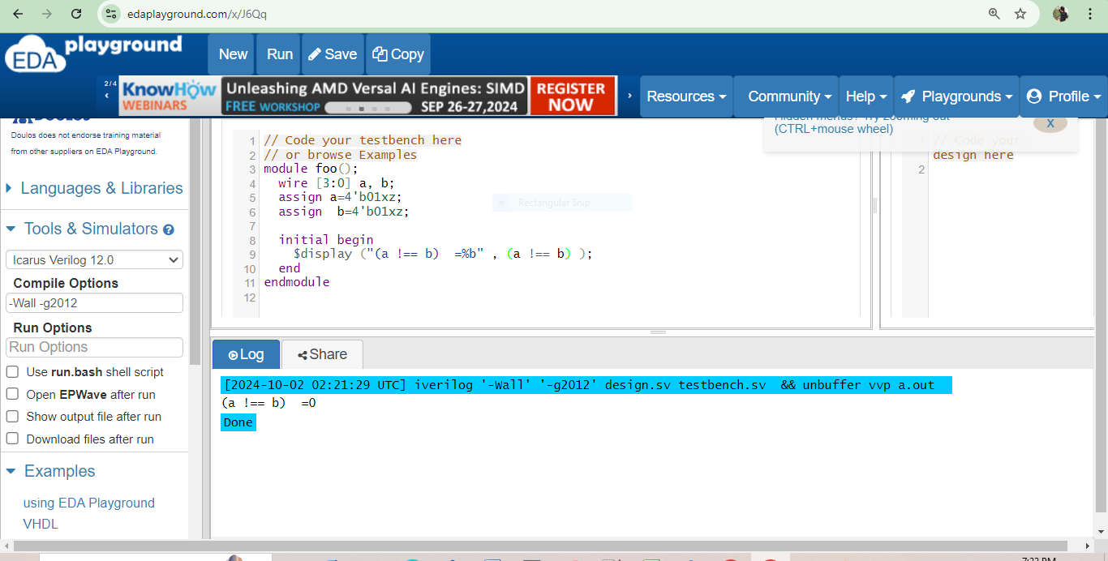

**//for (a == b)**

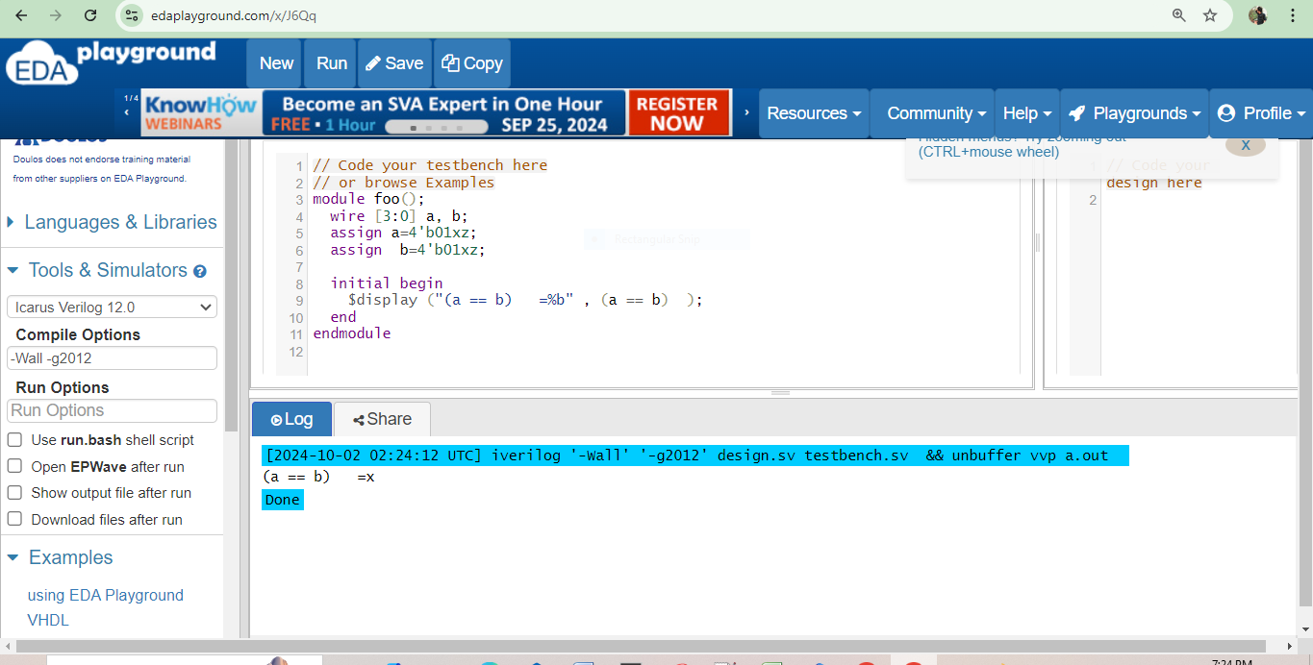

**//for** (a != b)

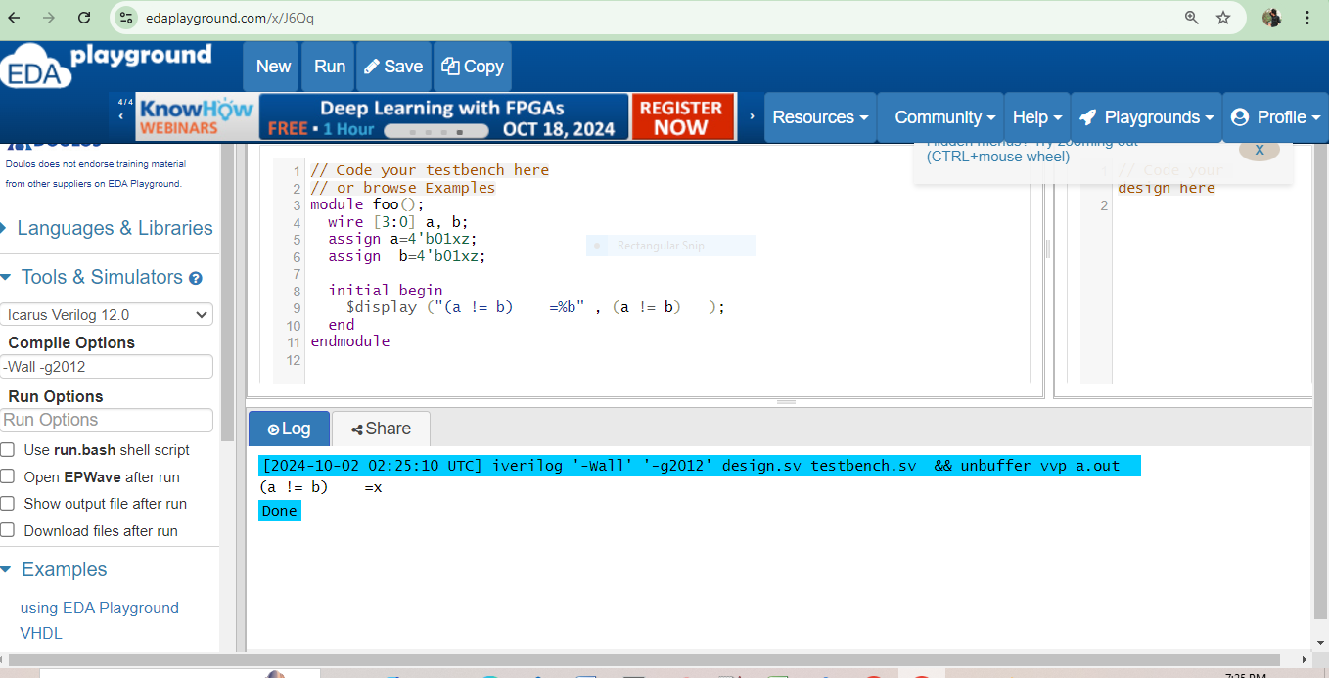

//If a = 4'01zz and b=4'b01zz

**//for (a == b)**

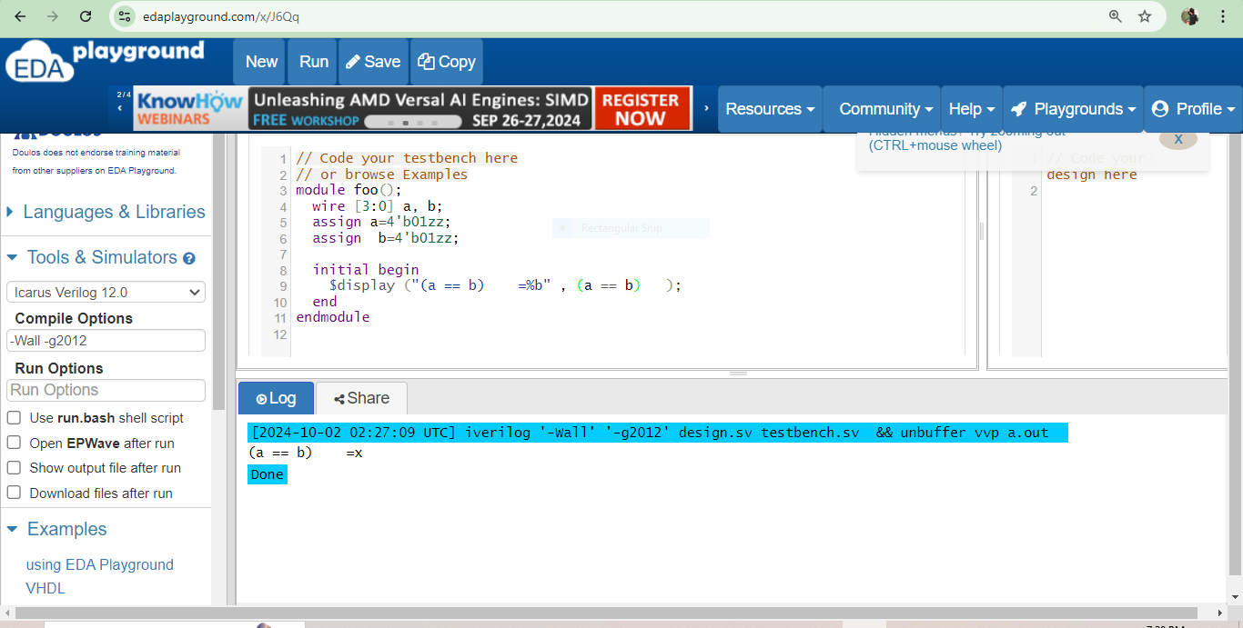

//for (a !=b)

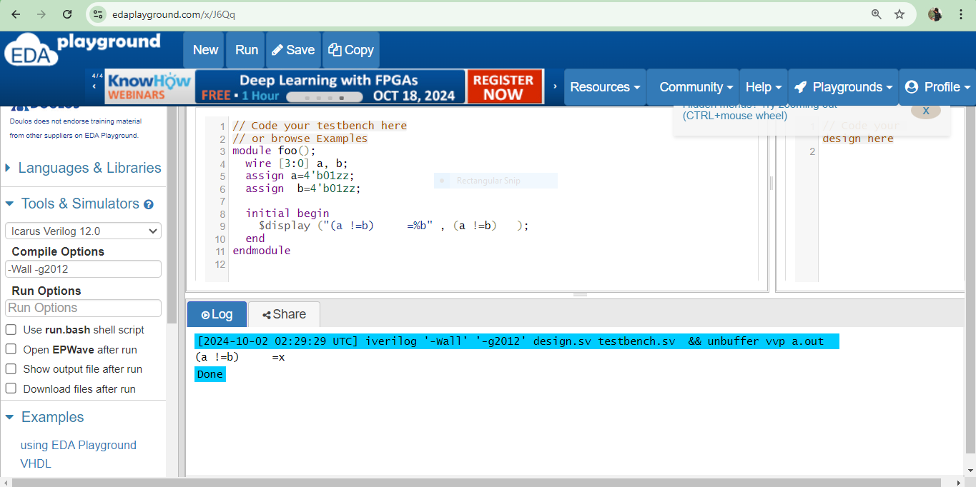

**4.**

module test_not_operator();

reg [2:0] A; // Maximum 3-bit value for 'A', including cases with unknowns

initial begin

// Display header

$display("A | !A");

// Test cases for 'A' and the results of !A

// 1-bit cases

A = 1'bx;

$display("1'bx | %b", !A);

A = 1'bz;

$display("1'bz | %b", !A);

// 2-bit cases

A = 2'b1z;

$display("2'b1z | %b", !A);

A = 2'b0z;

$display("2'b0z | %b", !A);

A = 2'bxz;

$display("2'bxz | %b", !A);

// 3-bit cases

A = 3'bxxx;

$display("3'bxxx | %b", !A);

A = 3'b1xx;

$display("3'b1xx | %b", !A);

A = 3'b0xx;

$display("3'b0xx | %b", !A);

end

endmodule

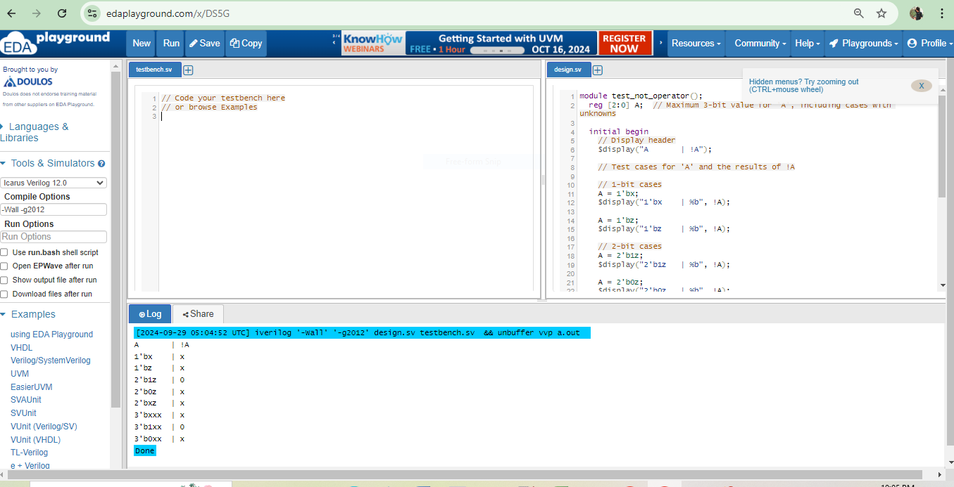

**5.**

module test_logical_operations();

reg A; // 1-bit value for 1'bx

reg [1:0] B; // 2-bit value for 2'bxz

reg [1:0] C; // 2-bit value for 2'b0x

reg [1:0] D; // 2-bit value for 2'b00

reg [1:0] E; // 2-bit value for 2'b1z

reg [3:0] F; // 4-bit value for 4'b01xz

initial begin

// Assign values

A = 1'bx; // 1'bx

B = 2'bxz; // 2'bxz

C = 2'b0x; // 2'b0x

D = 2'b00; // 2'b00

E = 2'b1z; // 2'b1z

F = 4'b01xz; // 4'b01xz

// Evaluate expressions and display results

$display("1'bx && 2'bxz | %b", A && B); // Logical AND

$display("2'b0x || 1'bz | %b", C || 1'bz); // Logical OR

$display("2'b00 && 2'b1z | %b", D && E); // Logical AND

$display("2'b0z || 4'b01xz | %b", 2'b0z || F); // Logical OR

end

endmodule

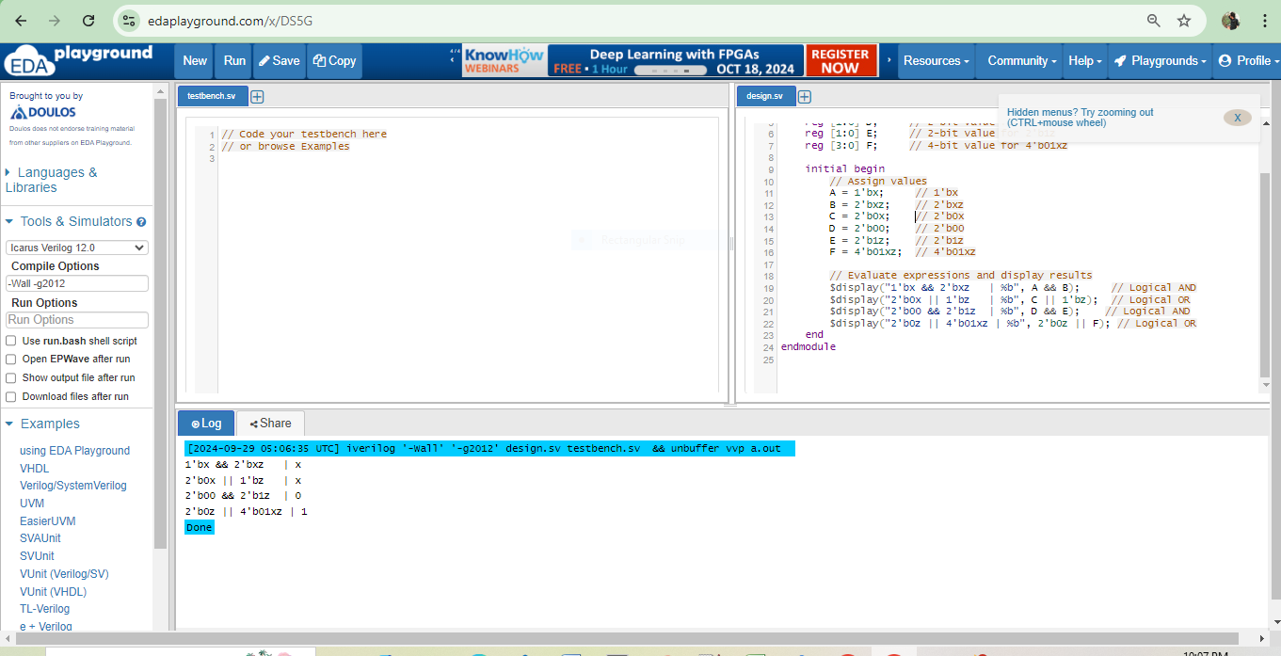

**6.**

module test_operations();

reg [3:0] A; // 4-bit variable

reg [3:0] B; // 4-bit variable

reg [1:0] C; // 2-bit variable

initial begin

// Assign values

A = 4'b01xz; // Example value for A with x and z

B = 4'bzx01; // Example value for B with z

C = 2'bz1; // Example value for C with z

// Evaluate expressions and display results

$display("~4'b01xz = %b", ~A); // Bitwise NOT

$display("4'b01xz & 4'bzx01 = %b", A & B); // Bitwise AND

$display("4'b01xz | 4'bzx01 = %b", A | B); // Bitwise OR

$display("4'b01xz ^ 4'bzx01 = %b", A ^ B); // Bitwise XOR

// Note: '~~' is not a standard operation, consider just using '~' for NOT

$display("~4'b01xz ~~ 4'bzx01 = %b", ~A); // Bitwise NOT (corrected)

$display("4'b01xz ^~ 2'bz1 = %b", A ^~ {2'b00, C}); // XNOR, padded to match bits

$display("4'b01xz ^~ 2'bz1 = %b", A ^~ {2'b00, C}); // For XNOR with 2'bz1 treated as 4'b?

end

endmodule

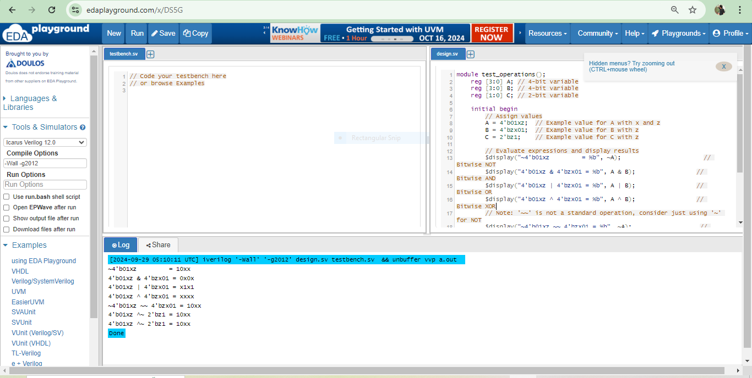

**7.**

module test_operations();

reg [3:0] A; // 4-bit variable

initial begin

// Assign value

A = 4'b01xz; // Example value for A with x and z

// Evaluate expressions and display results

$display("& 4'b01xz = %b", &A); // Bitwise AND reduction

$display("~| 4'b01xz = %b", ~|A); // Bitwise NOR reduction

$display("^ 4'b01xz = %b", ^A); // Bitwise XOR reduction

$display("~^ 4'b01xz = %b", ~^A); // Bitwise XNOR reduction

end

endmodule

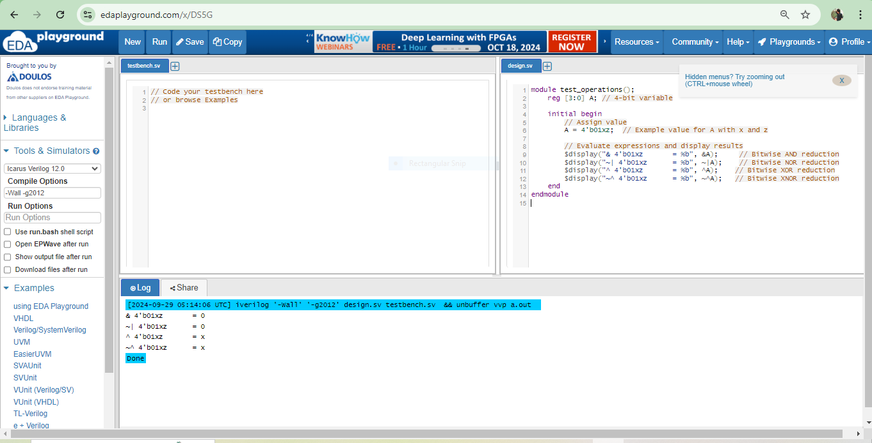

**8**.

module test_bit_shifting();

reg [3:0] A; // 4-bit variable

reg [1:0] shift_amount_right; // 2-bit shift amount for right shift

reg shift_amount_left; // 1-bit shift amount for left shift

reg [3:0] result_left; // Result of left shift

reg [3:0] result_right; // Result of right shift

initial begin

// Assign value

A = 4'b01xz; // Example value for A with x and z

shift_amount_left = 1'bz; // Indeterminate shift amount for left shift

shift_amount_right = 2'bxx; // Indeterminate shift amount for right shift

// Evaluate left shift and store result

result_left = A << shift_amount_left;

// Evaluate right shift and store result

result_right = A >> shift_amount_right;

// Display results

$display("4'b01xz << 1'bz = %b", result_left); // Left shift

$display("4'b01xz >> 2'bxx = %b", result_right); // Right shift

end

endmodule

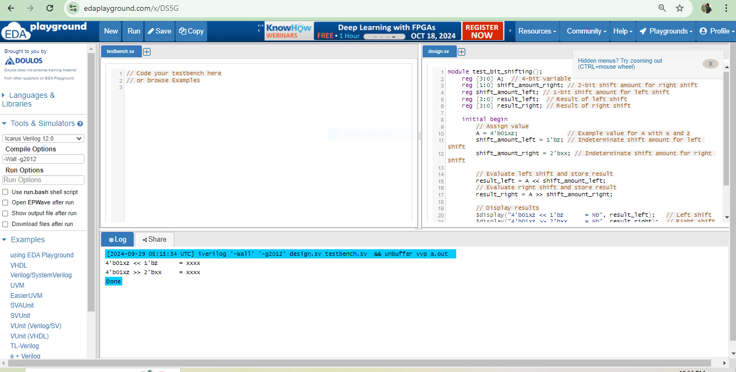

**9.**

module test_conditional();

reg [2:0] B; // 3-bit variable for the second case

reg [1:0] B_short; // 2-bit variable for the first case

reg [3:0] A; // 4-bit output

initial begin

// Case 1: B = 2'b1x

B_short = 2'b1x; // Assign value

A = B_short ? 4'b1100 : 5'b11ZX0; // Conditional assignment

$display("When B = 2'b1x, A = %b", A); // Display result

// Case 2: B = 3'b1xz

B = 3'b1xz; // Assign value

A = B ? 4'b1100 : 5'b11ZX0; // Conditional assignment

$display("When B = 3'b1xz, A = %b", A); // Display result

end

endmodule

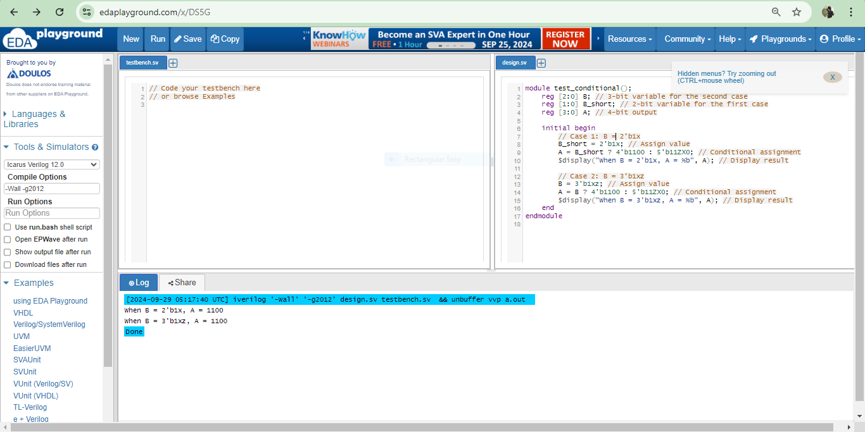

**10.**

module testStrength1();

reg a, b; // Data type declaration for a and b

wire y; // Data type declaration for y

// Define buffer gates with different strengths

bufif1 g1 (y, a, 1'b1); // A strong buffer from a, control is always 1 (enabled)

bufif0 g2 (y, b, 1'b0); // A weak buffer from b, control is always 0 (disabled)

initial begin

a = 1; // Set a to strong 1

b = 1; // Set b to weak 1

#1; // Wait for a moment to let signals propagate

$display("y = %b, a = %b, b = %b", y, a, b); // Display outputs

end

endmodule

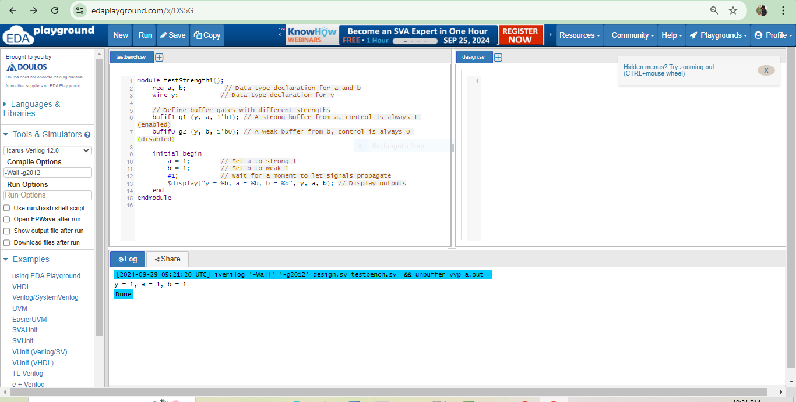

**Explanation:**

Since a is strong and b is weak, y will take the value of a. In this case, the expected output will be y = 1 because the strong driver (from a) will overpower the weak driver (from b).

module testStrength2();

reg i1, i2; // Data type declaration for i1 and i2

reg ctrl; // Control signal

wire y; // Data type declaration for y

// Define buffer gates with the same strength but different inputs

bufif0 g1 (y, i1, ctrl); // Buffer controlled by ctrl

bufif0 g2 (y, i2, ctrl); // Buffer controlled by ctrl

initial begin

ctrl = 1'bx; // Indeterminate state

i1 = 0; // Set i1 to 0

i2 = 1; // Set i2 to 1

#1; // Wait for a moment to let signals propagate

// Display output based on control signal

$display("y = %b", y);

end

endmodule

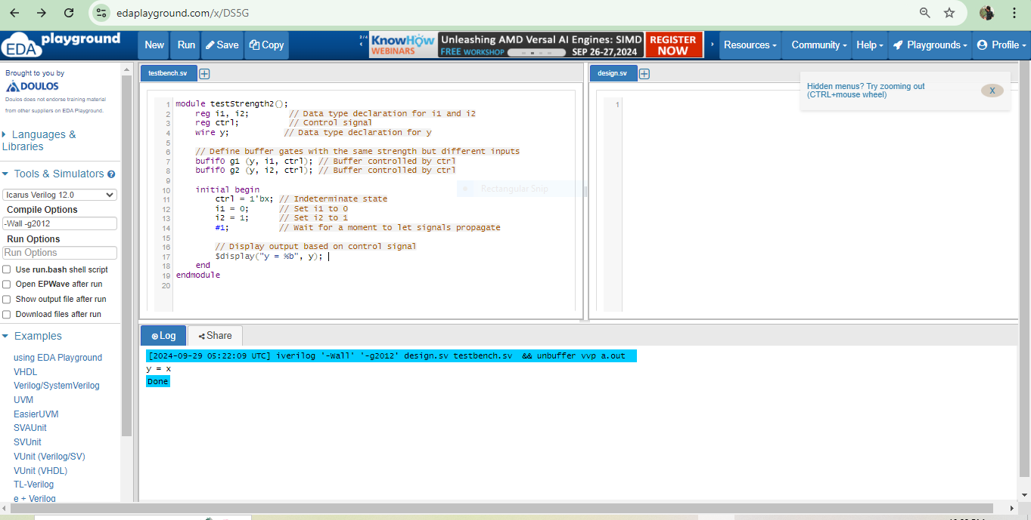

**Explanation:**

Because ctrl is initially x, the output y will also be x until ctrl is assigned a definite value. Since both drivers (i1 and i2) are weak (driving when ctrl is 0), the output strength remains weak until ctrl is resolved to either 0 or 1.

**11.**

`timescale 1ns/1ps // Add this line

module fourOneMux(

input i0_i, i1_i, i2_i, i3_i, // Data inputs

input s0_i, s1_i, // Select inputs

output out_o // Output

);

wire s0_n, s1_n; // Wires for NOT gates (inverted select lines)

wire y0, y1, y2, y3; // Wires for AND gate outputs

// Generate inverted select lines

not (s0_n, s0_i);

not (s1_n, s1_i);

// AND gates for each input and corresponding select lines

and (y0, i0_i, s1_n, s0_n); // y0 = i0 & ~s1 & ~s0

and (y1, i1_i, s1_n, s0_i); // y1 = i1 & ~s1 & s0

and (y2, i2_i, s1_i, s0_n); // y2 = i2 & s1 & ~s0

and (y3, i3_i, s1_i, s0_i); // y3 = i3 & s1 & s0

// OR gate to combine the AND gate outputs

or (out_o, y0, y1, y2, y3); // out = y0 | y1 | y2 | y3

endmodule

//TB

`timescale 1ns/1ps // Add this line

module fourOneMuxTB;

// Inputs to the MUX

reg i0_i, i1_i, i2_i, i3_i;

reg s0_i, s1_i;

// Output from the MUX

wire out_o;

// Instantiate the MUX

fourOneMux uut (

.i0_i(i0_i),

.i1_i(i1_i),

.i2_i(i2_i),

.i3_i(i3_i),

.s0_i(s0_i),

.s1_i(s1_i),

.out_o(out_o)

);

// Test process

initial begin

// Test Case 1: Select i0 (s1=0, s0=0)

i0_i = 1; i1_i = 0; i2_i = 0; i3_i = 0; s1_i = 0; s0_i = 0;

#10;

// Test Case 2: Select i1 (s1=0, s0=1)

i0_i = 0; i1_i = 1; i2_i = 0; i3_i = 0; s1_i = 0; s0_i = 1;

#10;

// Test Case 3: Select i2 (s1=1, s0=0)

i0_i = 0; i1_i = 0; i2_i = 1; i3_i = 0; s1_i = 1; s0_i = 0;

#10;

// Test Case 4: Select i3 (s1=1, s0=1)

i0_i = 0; i1_i = 0; i2_i = 0; i3_i = 1; s1_i = 1; s0_i = 1;

#10;

// Test Case 5: Random inputs and selections

i0_i = 1; i1_i = 0; i2_i = 1; i3_i = 1; s1_i = 1; s0_i = 0;

#10;

// Finish the simulation

$finish; // Use $finish to end the simulation cleanly

end

// Monitor the output during simulation

initial begin

$monitor("Time = %0d, i0 = %b, i1 = %b, i2 = %b, i3 = %b, s1 = %b, s0 = %b, out = %b",

$time, i0_i, i1_i, i2_i, i3_i, s1_i, s0_i, out_o);

end

endmodule

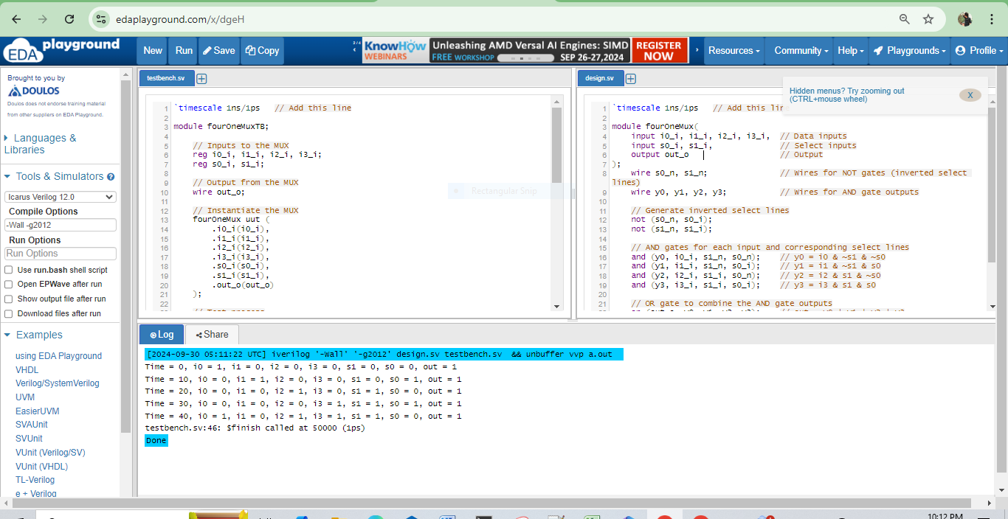

**12.**

`timescale 1ns/1ps

module nor_gate_switch (

input A, B, // Inputs A and B

output reg Out // Output of the NOR gate

);

always @(*) begin

Out = ~(A | B); // NOR operation

end

endmodule

//tb

`timescale 1ns/1ps

module nor_gate_tb;

// Inputs

reg A, B;

// Output

wire Out;

// Instantiate the NOR gate

nor_gate_switch uut (

.A(A),

.B(B),

.Out(Out)

);

// Test process

initial begin

// Initialize inputs

A = 0; B = 0; // Test case 1

#10;

A = 0; B = 1; // Test case 2

#10;

A = 1; B = 0; // Test case 3

#10;

A = 1; B = 1; // Test case 4

#10;

// Finish simulation

$finish;

end

// Monitor outputs

initial begin

$monitor("Time = %0d, A = %b, B = %b, Out = %b", $time, A, B, Out);

end

endmodule

